CYBER SECURITY WITH KALI LINUX
A Summer Internship Report submitted in partial fulfillment of the
requirements for the award of a degree of

BACHELOR OF TECHNOLOGY
In
CSE-AIML

Submitted by:
GUNNAM PREETHI ASHRITHA
22P31A4215



CSE-AIML
ADITYA COLLEGE OF ENGINEERING & TECHNOLOGY (A)
Approved by AICTE, permanently affiliated to JNTUK & Accredited by NAAC with ‘A⁺’ Grade
Recognized by UGC under the sections 2(f) and 12(B)of the UGC act 1956
Aditya Nagar, ADB Road –Surampalem 533437, E.G. Dist., A.P.,
2024-2025.

ADITYA COLLEGE OF ENGINEERING & TECHNOLOGY (A)

Approved by AICTE, Permanently Affiliated to JNTUK & Accredited by NAAC with ‘A⁺’ Grade
Recognized by UGC under the sections 2(f) and 12(B) of the UGC act 1956
Aditya Nagar, ADB Road - Surampalem – 533437, E.G.Dist., A.P.,

Department of CSE-AIML



CERTIFICATE

This is to certify that the Internship report entitled “Keylogger and Security” is being submitted by Gunnam Preethi Ashritha (22P31A4215).
In partial fulfillment of the requirements for award of the B. Tech degree in
CSE-AIML for the academic year 2024-2025.

Internship Guide Head of the Department
Dr. B. S. N. V. Ramana Murthy _{M. Tech (Ph. D)} Dr. K. Naga Bhargavi _{M.Tech., Ph. D}
Sr. Associate Professor

DECLARATION

I hereby declare that the Internship entitled “Cyber Security with Kali Linux” is a genuine report. This work has been submitted to the ADITYA COLLEGE OF ENGINEERING & TECHNOLOGY (A), Surampalem, permanently affiliated to JNTUK, KAKINADA in partial fulfillment of the B. Tech degree.
I also hereby declare that this internship report is not submitted in full or partial to any other university for any degree.

Gunnam Preethi Ashritha
(22P31A4215)

 _________________________________________________________________________________________

INSTITUTE VISION AND MISSION

VISION:
To induce higher planes of learning by imparting technical education with
- International standards
- Applied research
- Creative Ability
- Value based instruction and to emerge as a premiere institute
MISSION:
Achieving academic excellence by providing globally acceptable technical education by forecasting technology through
- Innovative research and development
- Industry institute interaction
- Empowered manpower


PRINCIPAL

AI & ML
VISION & MISSION OF THE DEPARTMENT
VISION
To be a recognized Computer Science and Engineering hub striving to meet the growing needs of the Industry and Society.

MISSION
M1: Imparting Quality Education through state-of-the-art infrastructure with industry collaboration.

M2: Enhance Teaching Learning Process to disseminate knowledge.

M3: Organize Skill based, Industrial and Societal Events for overall Development

PROGRAMME EDUCATIONAL OBJECTIVES (PEOS)
PEO1: | Proficiency in Al & ML. Applications Expertise in designing, developing and deploying Al and ML solutions for healthcare, finance, and autonomous system problems
PEO2: | Lifelong Learning a and Adaptability Adapt to evolving technologies and industry trends in Al and M. through continuous learning and self-improvement
PEO3: | Effective Communication and Collaboration Possess strong communication mating them to effectively collaborate with interdisciplinary teams and solve complex problems using Al and ML concepts

PROGRAMME SPECIFIC OUTCOMES (PSOS)
PSO1: | AI and ML system development  Design and develop, and implement AI and ML systems by applying fundamental principles, algorithms and techniques
PSO2: | Data-Driven Decision-Making  Collect, Preprocess and analyze large and diverse datasets to extract meaningful insights using AI and ML techniques to support data-driven decision-making processes in various domains.
INTERNSHIP COMPLETION CERTIFICATE

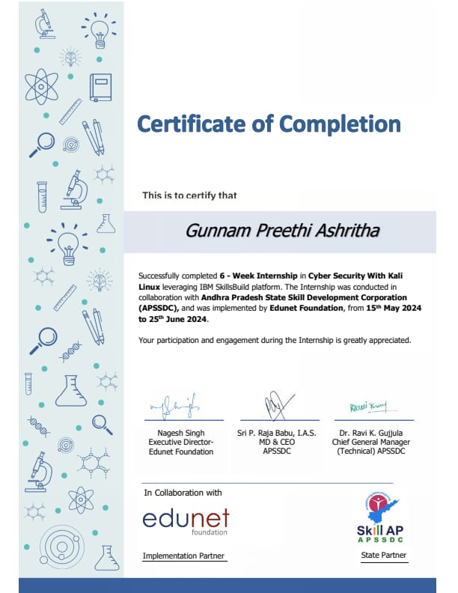

ACKNOWLEDGEMENT
I offer my sincere thanks to the dynamic and beloved Principal, Dr. A. Ramesh _{M. Tech, Ph. D,} Aditya College of Engineering & Technology (A) for his cooperation.
We feel delighted to thank Dean (Academics), Dr. P. S. V. V. S. RAVI KUMAR _{M.Tech., Ph. D}, of Aditya College of Engineering and Technology (A) for his cooperation in completion of our project work.
My sincere thanks to Head of the Department, Dr. K. Naga Bhargavi _{M.Tech., Ph. D,} of CSE (AIML) for her valuable support.
I express my sincere gratitude to my internship guide, Dr. B. Manikyala Rao _{M.Tech., Ph. D,} Associate Professor, Department of CSE (AIML), for his valuable guidance and encouragement which has been helpful in the successful completion of this internship.
With immense pleasure, I would like to express my deep sense and heart full thanks to the management of Aditya College of Engineering & Technology (A).

Learning Objectives / Internship Objectives

1. Understanding of Cybersecurity Fundamentals

2. Proficiency with Kali Linux

3. Network Security and Monitoring

4. Web Application Security

5. Vulnerability Assessment and Reporting

6. Understanding of Emerging Threats

7. Collaboration and Communication Skills

Index

Sl. No | CONTENT | PAGE No.
1. | Executive Summary | 1
2. | Overview of Organization  2.1 Introduction to Organization  2.2 Vision, Mission & Values of Organization  2.3 Policy of Organization, in relation to intern  Role  2.4 Roles and responsibilities of the employees  2.5 Performance of the Organization  2.6 Future Plans of the Organization | 2-6
3. | Internship part | 7
4. | Weekly overview of internship activities:  4.1 Activity log for the First Week  4.2 Activity log for the Second Week  4.3 Activity log for the Third Week  4.4 Activity log for the Fourth Week  4.5 Activity log for the Fifth Week  4.6 Activity log for the Sixth Week | 8-19
5. | Outcomes Description | 20
6. | Photos & Video links | 23

CHAPTER 1: Executive Summary

I Successfully completed my internship Cyber security with kali Linux leveraging IBM Skills Build Platform. The Internship was conducted in collaboration with Andhra Pradesh State Skill Development Corporation (APSSDC) and was implemented by Edu net Foundation which focuses on helping underprivileged Students gain access to tech education and job opportunities in areas like AI, Cybersecurity and Cloud Computing. They partner with IBM and Microsoft to offer Certifications and hands-on training. Edunet Foundation is an Indian non-profit that provides skill development in areas like AI, cybersecurity, and cloud computing. They partner with tech giants like IBM and Microsoft to offer certifications and hands-on training. This foundation focuses on helping underprivileged students gain access to tech education and job opportunities. They also support teacher training to enhance tech-based teaching methods. Through internships and real-world projects, Edunet prepares learners for the modern job market. This Cybersecurity with Kali Linux internship aims to teach students how to use Kali Linux tools for ethical hacking and security testing. Interns learn to conduct penetration testing, identify vulnerabilities, and secure networks and systems. They gain hands-on experience with tools like Nmap, Wireshark, and Metasploit for tasks like network scanning and web application security. The internship also covers key areas like cryptography, incident response, and wireless security. Overall, it helps interns develop the practical skills needed to protect digital systems and prepares them for cybersecurity roles.

CHAPTER 2: Overview of the Organization

2.1 Introduction of the Organization

Andhra Pradesh State Skill Development Corporation (APSSDC) is a government organization that helps people in Andhra Pradesh get the skills they need for good jobs.

APSSDC offers training in many areas like IT, manufacturing and healthcare to make sure people are ready for the workforce.

Its main goal is to provide training that prepares people for the real-world needs of industries, ensuring they are ready for employment or entrepreneurship.

APSSDC partners with schools, colleges, industries and various other groups to make skill training available to everyone in the state.

They also focus on enhancing skills in new technologies like artificial intelligence, machine learning, and data science.

The idea is to bridge the gap between what people learn in school and the skills needed in the job market, making sure the youth of Andhra Pradesh are well prepared for employment.

Edunet Foundation is an Indian non-profit that provides skill development in areas like AI, cybersecurity, and cloud computing. They partner with tech giants like IBM and Microsoft to offer certifications and hands-on training.

This foundation focuses on helping underprivileged students gain access to tech education and job opportunities.

2.2 Vision, Mission & Values of organization

VISION

To make Andhra Pradesh a place where everyone is equipped with the right skills to succeed in the modern job market.

The vision is to create a skilled workforce that meets the demands of industries, ensuring growth and prosperity for the states.

MISSION

To provide high-quality training that prepares people for jobs in various sectors.

To work with industries and educational institutions to create skill development opportunities.

To ensure that the training offered matches the requirements of the industry, helping people become job-ready.

To support individuals who want to start their own businesses by offering entrepreneurship training and resources.

VALUES

APSSDC values inclusivity, quality, innovation, collaboration, and sustainability in its skill development.

They aim to provide accessible, high-quality training while fostering partnerships and ensuring long-term career growth.

2.3 Policy of the Organization, in relation to the intern role
- APSSDC (Andhra Pradesh State Skill Development Corporation) has a clear policy for interns to ensure a valuable and practical learning experience.
- Interns are expected to take part in all tasks with a positive attitude, showing professionalism, responsibility, and a strong desire to learn.
- They must follow the organization’s ethical guidelines, respect confidentiality, and meet deadlines.
- Teamwork is important, and interns are encouraged to work closely with others and build new skills in their field.

  - Organizational Structure
- APSSDC's organizational structure is led by a Board of Directors, responsible for key decisions and setting goals.
- The Managing Director oversees the daily operations and leads the organization.
- Various departments like Training, Operations, Finance, and HR, each headed by a department leader, manage skill development programs.
- Regional officers ensure effective implementation of programs at the regional level.
- Trainers and administrators support the organization’s mission of enhancing skills and employability

Roles and responsibilities of Employees in which

Intern is placed:

Training Department: Employees create and run training programs. They make sure that what people learn is useful and relevant to the job market.

Operations Department: These employees handle the scheduling, organizing, and smooth running of training sessions and projects.

Finance Department: Employees here manage the organization's money, making sure funds are used wisely for different programs and expenses.

Human Resources Department: HR employees take care of hiring, onboarding, and supporting the staff. They also make sure, the team is happy and productive.

Regional Officers: They oversee programs in different regions, ensuring everything goes according to plan and making adjustments if needed.

Performance of the Organization:

Turnover: APSSDC generates its revenue primarily through government funding and partnerships, as it focuses on skill development rather than profit-making.

Profits: As a government-backed organization, APSSDC focuses more on social impact and training outcomes rather than profits.

Market Reach: APSSDC provides training across Andhra Pradesh, reaching both urban and rural areas.

Market Value: APSSDC’s value is in improving employability and boosting the state's workforce.

Future Plans of the Organization:

Establishment of Skill University and Colleges: Setting up a skill university and 30 skill colleges across the state to provide advanced vocational training​ (The New Indian Express)​(AP Breaking News).

Industry Collaboration: Partnering with over 55 industries (like IBM, Mahindra, Dell) to offer industry-tailored skill programs that improve employability​ (The New Indian Express)​(The New Indian Express).

Global Opportunities: Launching the "Skill International" initiative to help youth find jobs abroad, with early success in placing nurses in Germany ​(The New Indian Express).

Agri-Tech and Digital Training: Expanding training in agriculture, allied sectors, and digital literacy, especially for farmers and rural women ​(AP Breaking News).

Customized Training Programs: Focus on demand-driven skill development to meet specific industry needs, enhancing job placements​ (The New Indian Express)​(AP Breaking News).

These initiatives aim to reduce unemployment and create a globally recognized skilled workforce.

CHAPTER 3: Internship Part

During the internship with the cybersecurity program focused on Kali Linux, the activities and responsibilities encompassed a variety of tasks and experiences that contributed to a well-rounded learning environment.

Interns typically followed a structured weekly work schedule, consisting of combination of lectures, hands-on practical sessions, and project work. Most weeks included three to four live sessions, lasting about two to three hours each, supplemented by additional self-study and practice hours. This schedule allowed interns to balance their time effectively between learning new concepts and applying them in practical scenarios.

The working conditions were primarily online, providing flexibility in terms of location. Interns utilized personal computers or laptops equipped with the necessary software, including Kali Linux and other cybersecurity tools. Virtual labs facilitated a hands-on experience where interns could practice penetration testing, network analysis, and vulnerability assessments in a controlled environment.

Key tasks performed during the internship included conducting system audits, performing network scans, and learning to identify vulnerabilities using various tools available in Kali Linux. Interns engaged in team projects that involved real-world scenarios, such as simulating attacks and defenses, which fostered teamwork and collaboration.

Through these activities, interns acquired a range of valuable skills, including technical proficiency in cybersecurity tools, critical thinking in identifying and solving security issues, and enhanced collaboration and communication skills while working with peers.

WEEKLY OVERVIEW OF INTERNSHIP ACTIVITIES

4.1 ACTIVITY LOG FOR THE FIRST WEEK

1stWEEK | Date | Day | Brief Description of Daily Activity | Learning Outcomes
1stWEEK | 15-05-24 | Wednesday | Joined Telegram group and verifying the mail. | Understanding the Internship pattern and schedule
1stWEEK | 16-05-24 | Thursday | Introduction to Skills Build platform, registration, and setting up profiles. | Understanding how to navigate the Skills Build platform and set up a profile
1stWEEK | 17-05-24 | Friday | Exploring available resources, courses, and certifications within the platform | Familiarity with various courses and resources offered on skills build.
1stWEEK | 18-05-24 | Saturday | Overview of learning paths and career opportunities in cybersecurity. | Awareness of career options and skills required in cybersecurity.
1stWEEK | 20-05-24 | Monday | Introduction to the IBM Skills Build community and networking with peers. | Networking skills and the importance of community in learning
1stWEEK | 21-05-24 | Tuesday | Understanding the structure of the upcoming course and expectations for participants. | Clarity on course structure, deadlines.

WEEKLY REPORT
WEEK – 1 (From 15-05-24 to 21-05-24)

Objective of the Activity Done: Skills Build Orientation
Detailed Report:
In the first week, participants are introduced to the IBM SkillsBuild platform, where they set up their profiles and explore available resources like courses and certifications. They learn about different career paths in cybersecurity and get familiar with the platform’s tools. By midweek, they connect with other learners and the SkillsBuild community to start building a network. The week wraps up with a clear explanation of the course structure, deadlines, and expectations, helping participants feel ready to begin their learning journey.

4.2 ACTIVITY LOG FOR THE SECOND WEEK

2nd WEEK | Date | Day | Brief Description of Daily Activity | Learning Outcomes
2nd WEEK | 22-05-24 | Wednesday | Overview of cybersecurity concepts, threats, and defenses. | Understanding basic cybersecurity concepts and key threats.
2nd WEEK | 23-05-24 | Thursday | Introduction to networking concepts (OSI Model, IP addressing, etc.). | Grasping network architecture and protocols (OSI Model).
2nd WEEK | 24-05-24 | Friday | Basics of firewalls, encryption, and VPNs for securing networks. | Understanding of firewalls, encryption techniques, and VPN usage.
2nd WEEK | 25-05-24 | Saturday | Holiday | Holiday
2nd WEEK | 27-05-24 | Monday | Network security tools and their application in real-world scenarios. | Hands-on experience with network security tools and their configurations.
2nd WEEK | 28-05-24 | Tuesday | Recap session and quiz on basic cybersecurity and networking concepts. | Reinforcement of key learning points through review and assessment.

WEEKLY REPORT
WEEK – 2 (From 22-05-24 to 28-05-24)

Objective of the Activity Done: Introduction & Basic Networking
Detailed Report:
In Week 2, participants dive into the basics of cybersecurity and networking. They start by learning key cybersecurity concepts, such as common threats and how to defend against them. Next, they explore networking fundamentals, including the OSI model and how data moves through networks. Throughout the week, they also get introduced to important tools like firewalls, encryption methods, and VPNs to secure networks. By the end of the week, participants practice using network security tools and review everything with a quiz, reinforcing their understanding of these foundational topics.

4.3 ACTIVITY LOG FOR THE THIRD WEEK

3rdWEEK | Date | Day | Brief Description of Daily Activity | Learning Outcomes
3rdWEEK | 29-05-24 | Wednesday | Introduction to Kali Linux and its importance in cybersecurity. | Understanding the role of Kali Linux in cybersecurity operations.
3rdWEEK | 30-05-24 | Thursday | Installing Kali Linux and familiarizing with the environment. | Hands-on experience with installing and navigating Kali Linux.
3rdWEEK | 31-05-24 | Friday | Basic Linux commands essential for cybersecurity operations. | Ability to use basic Linux commands in Kali Linux.
3rdWEEK | 01-06-24 | Saturday | Introduction to Kali Linux tools (e.g., Nmap, Wireshark). | Knowledge of essential tools in Kali Linux for penetration testing.
3rdWEEK | 03-06-24 | Monday | Running a simple network scan using Kali Linux tools. | Application of Kali Linux tools in real-world cybersecurity tasks.
3rdWEEK | 04-06-24 | Tuesday | Practicing the Simple Kali Linux commands | Gaining the practical knowledge.
WEEKLY REPORT
WEEK – 3 (From 29-05-24 to 04-06-24)

Objective of the Activity Done: Explanation on Kali Linux
Detailed Report:
In Week 3, participants focus on Kali Linux, a key tool for cybersecurity tasks. They begin by learning what Kali Linux is and why it’s important in the field. After that, they install the software and get familiar with the basic commands used in Linux systems. As the week progresses, participants explore some of Kali Linux’s powerful tools, like Nmap and Wireshark, which are used for network scanning and traffic analysis. The week ends with a hands-on activity where participants perform a basic network scan using these tools, giving them practical experience in real-world cybersecurity operations.

4.4 ACTIVITY LOG FOR THE FORTH WEEK

4thWEEK | Date | Day | Brief Description of Daily Activity | Learning Outcomes
4thWEEK | 05-06-24 | Wednesday | Understanding social engineering: Phishing, baiting, and pretexting. | Recognizing different types of social engineering attacks.
4thWEEK | 06-06-24 | Thursday | Real-life case studies of social engineering attacks and their impact. | Awareness of real-world social engineering tactics and their consequences.
4thWEEK | 07-06-24 | Friday | Key Logger Project: Introduction to key loggers, their role in cyberattacks, and setting up a key logger in a controlled environment. | Hands-on experience in setting up and understanding how key logger’s work.
4thWEEK | 08-06-24 | Saturday | Holiday | Holiday
4thWEEK | 10-06-24 | Monday | Analyzing the data captured and understanding the ethical implications of using key loggers. | Ability to analyze captured data and understand ethical boundaries of cyber tools.
4thWEEK | 11-06-24 | Tuesday | Presentation of the Key Logger project results, lessons learned, and how to defend against key logger attacks. | Skill in presenting project findings and developing countermeasures for key logger attacks.

WEEKLY REPORT
WEEK – 4 (From 05-06-24 to 11-06-24)

Objective of the Activity Done: Social Engineering attacks and Project Work
Detailed Report:
In Week 4, participants explore social engineering attacks, including phishing, baiting, and pretexting. They examine real-life case studies to understand the impact of these attacks on organizations. Midweek, they start a Key Logger Project, where they learn how key loggers work and set one up in a controlled environment to see how data can be captured. They then analyze the collected data and discuss the ethical implications of using such tools. The week wraps up with presentations of the key logger project results and a discussion on how to defend against key logger attacks, reinforcing both technical skills and ethical awareness.

4.5 ACTIVITY LOG FOR THE FIFTH WEEK

5thWEEK | Date | Day | Brief Description of Daily Activity | Learning Outcomes
5thWEEK | 12-06-24 | Wednesday | Overview of system hacking techniques (password cracking, privilege escalation, etc.). | Understanding the techniques hackers use to breach systems.
5thWEEK | 13-06-24 | Thursday | Practical demonstration: Brute-force attacks and password cracking methods. | Hands-on experience with password cracking techniques.
5thWEEK | 14-06-24 | Friday | Introduction to privilege escalation and exploiting system vulnerabilities. | Understanding how hackers gain elevated access through privilege escalation.
5thWEEK | 15-06-24 | Saturday | Ethical hacking: Using penetration testing tools to identify system weaknesses. | Skills in ethical hacking and using penetration testing tools responsibly.
5thWEEK | 17-06-24 | Monday | Defending against system hacks: Implementing security measures and best practices. | Knowledge of defense strategies against system hacking techniques.
5thWEEK | 18-06-24 | Tuesday | Implementation of Key Logger Project using python. | Knowledge on Python Various modules.

WEEKLY REPORT
WEEK – 5 (From 12-06-24 to 18-06-24)

Objective of the Activity Done: System Hacking
Detailed Report:
In Week 5, participants delve into system hacking techniques, starting with an overview of methods like password cracking and privilege escalation. They engage in practical demonstrations of brute-force attacks, learning how hackers attempt to break into systems by guessing passwords. As the week progresses, they focus on privilege escalation, understanding how attackers gain unauthorized access to higher levels of system control. Participants also explore ethical hacking practices, using penetration testing tools to identify system vulnerabilities responsibly. The week concludes with a discussion on defensive strategies to protect systems from these hacking techniques, equipping participants with both offensive and defensive cybersecurity skills.

4.6 ACTIVITY LOG FOR THE SIXTH WEEK

6thWEEK | Date | Day | Brief Description of Daily Activity | Learning Outcomes
6thWEEK | 19-06-24 | Wednesday | Introduction to data security: Importance of encryption, backups, and access control. | Understanding methods to secure sensitive data and prevent data breaches.
6thWEEK | 20-06-24 | Thursday | Encrypting files and setting up secure backups. | Hands-on experience with encryption techniques and securing data.
6thWEEK | 21-06-24 | Friday | Finalizing the key logger project, analyzing results, and preparing for submission. | Ability to synthesize project findings and present data securely.
6thWEEK | 22-06-24 | Saturday | Holiday | Holiday
6thWEEK | 24-06-24 | Monday | Final project submission: Presenting the key logger project and discussing its implications and defenses. | Skill in presenting cybersecurity projects and understanding countermeasures.
6thWEEK | 25-06-24 | Tuesday | Feedback and course review: Discussing key takeaways and future learning paths. | Reflection on learning outcomes and identifying next steps in cybersecurity.

WEEKLY REPORT
WEEK – 6 (From 19-06-24 to 25-06-24)

Objective of the Activity Done: Secure data to prevent Hackers & Project Submission
Detailed Report:
In Week 6, participants focus on data security, learning about the importance of encryption, backups, and access control in protecting sensitive information. They start with a practical session on encrypting files and setting up secure backups to safeguard data. Midweek, they finalize their Key Logger Project, analyzing the results and preparing their findings for submission. The week culminates in presentations where participants showcase their key logger projects, discussing the implications of their findings and how to defend against such attacks. Finally, the course wraps up with feedback sessions and discussions on key takeaways, helping participants reflect on their learning and identify future steps in their cybersecurity journey.

CHAPTER 5: Outcomes Description

- The program fostered a collaborative atmosphere where interns frequently interacted with each other and instructors, encouraging open dialogue and question-asking. This interaction promoted a sense of community and support among participants. Mentors were approachable, providing valuable insights and guidance, making it easier for interns to seek help when needed.
- Access to online platforms for lectures and hands-on sessions was well-maintained and user-friendly. Virtual labs allowed interns to practice their skills in a safe environment, ensuring they could apply theoretical knowledge effectively. The overall infrastructure supported a seamless learning experience.
- Job roles and expectations were clearly defined at the outset, enabling interns to focus on their individual learning objectives. This clarity helped interns understand their responsibilities, ensuring a structured approach to their work and learning tasks. Regular feedback on performance further reinforced role clarity.
- The program adhered to a structured curriculum, blending theoretical and practical components that facilitated comprehensive learning. Interns were expected to follow specific protocols during practical sessions, which instilled discipline and a professional approach to cybersecurity practices. Timelines and deadlines encouraged effective time management.
- Interns built harmonious relationships through collaborative projects, which enhanced both socialization and teamwork skills. Networking opportunities allowed participants to share ideas and experiences, fostering a supportive environment. Recognition of individual contributions by instructors boosted morale and motivation, driving a shared commitment to learning.

Student Self-Evaluation of the Short-Term Internship

Student Name: Gunnam Preethi Ashritha

Registration No: 22P31A4215

Duration of Internship: 6 weeks

From: 15th May 2024 To: 25th June 2024

Date of Evaluation:

Organization Name & Address:

Please rate your performance in the following areas:

Rating Scale: Letter grade of CGPA calculation to be provided

1 | Oral communication | 1 | 2 | 3 | 4 | 5
2 | Written communication | 1 | 2 | 3 | 4 | 5
3 | Interaction ability with the community | 1 | 2 | 3 | 4 | 5
4 | Positive Attitude | 1 | 2 | 3 | 4 | 5
5 | Self-confidence | 1 | 2 | 3 | 4 | 5
6 | Ability to learn | 1 | 2 | 3 | 4 | 5
7 | Work Plan and Organization | 1 | 2 | 3 | 4 | 5
8 | Quality of work done | 1 | 2 | 3 | 4 | 5
9 | Time Management | 1 | 2 | 3 | 4 | 5
10 | Achievement of Desired Outcomes | 1 | 2 | 3 | 4 | 5
OVERALL PERFORMANCE

Student Signature

Evaluation by the Supervisor of the Intern Organization

Student Name: Gunnam Preethi Ashritha

Registration No: 22P31A4215

Duration of Internship: 6 weeks

From: 15th May 2024 To: 25th June 2024

Date of Evaluation:

Organization Name & Address:

Name & Address of the Supervisor with Mobile Number

Please rate the student’s performance in the following areas:

Please note that your evaluation shall be done independent of the student’s self-evaluation

Rating Scale: 1 is the lowest and 5 is the highest rank

1 | Oral communication | 1 | 2 | 3 | 4 | 5
2 | Written communication | 1 | 2 | 3 | 4 | 5
3 | Interaction ability with the community | 1 | 2 | 3 | 4 | 5
4 | Positive Attitude | 1 | 2 | 3 | 4 | 5
5 | Self-confidence | 1 | 2 | 3 | 4 | 5
6 | Ability to learn | 1 | 2 | 3 | 4 | 5
7 | Work Plan and Organization | 1 | 2 | 3 | 4 | 5
8 | Quality of work done | 1 | 2 | 3 | 4 | 5
9 | Time Management | 1 | 2 | 3 | 4 | 5
10 | Achievement of Desired Outcomes | 1 | 2 | 3 | 4 | 5
OVERALL PERFORMANCE

Signature of the Supervisor

PHOTOS & VIDEO LINK

Photos:

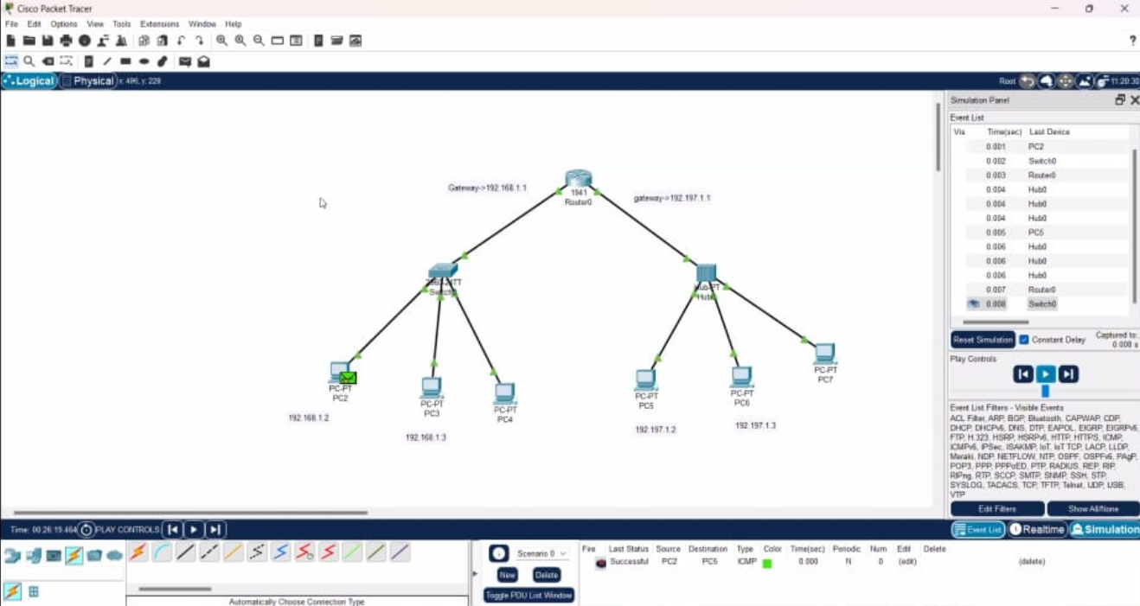
Fig: Cisco packet tracer – connecting the PC’s

Video links:

- https://edunetfoundationorg-
- my.sharepoint.com/:f:/g/personal/anusha_edunetfoundation_org/EsbBR1lB43JAmr3rZamUkEQBJ6BAUALKkqMKtP_5dau7BQ

Project Link:

https://github.com/PREETHI-ASHRITHA/cybersecurity.git

